Experiment 14
Implement House price Prediction using appropriate machine learning algorithm
Aim
To implement a House Price Prediction model using an appropriate Machine Learning algorithm (Linear Regression) in Python.
Program
# House Price Prediction using Linear Regression
import pandas as pd
from sklearn.linear_model import LinearRegression
from sklearn.metrics import mean_squared_error
# Dataset
data = {
'Area': [1000, 1200, 1500, 1800, 2000],
'Bedrooms': [2, 3, 3, 4, 4],
'Price': [3000000, 3500000, 4000000, 5000000, 5500000]
}
df = pd.DataFrame(data)
# Features and target
X = df[['Area','Bedrooms']]
y = df['Price']
# Model
model = LinearRegression()
model.fit(X, y)
# Prediction
y_pred = model.predict(X)
print("Actual Prices:", list(y))
print("Predicted Prices:", list(y_pred))

# Error
mse = mean_squared_error(y, y_pred)
print("Mean Squared Error:", mse)
Output
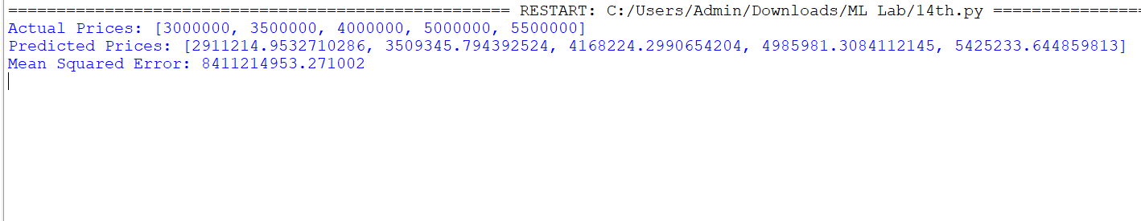

Result
The House Price Prediction model was successfully implemented in Python using Linear Regression, and the predicted prices were generated based on the given house features.

